Coral ECA Fisheries Stakeholder

Committee - Meeting 11 part 1

Virtual meeting via Zoom

6-8 pm, Tuesday April 12th 2022

Summary – April 12th
Overview
On Tuesday, April 22nd the second part of two of the twelfth Fishery Stakeholder Committee meetings was held virtually via Zoom. Project principal investigator Kai Lorenzen, facilitator Joy Hazell, and cofacilitator Susana Hervas attended the meeting.
Eleven committee members, four members of the public, two Florida Fish and Wildlife Conservation Commission staff, and two Florida Department of Environmental Protection employees attended the meeting.
The meeting objectives were to:
- Review emerging recommendations

Welcome
The start of the meeting was a quick presentation with an explanation and clarification of the meeting agenda and objectives, reminder of group norms – highlighting listen carefully, consider each idea, and tough on the issues, not on the people - and sunshine law (Slides in Appendix 1). This meeting picked up where it was left on Tuesday. Committee members had expressed a need to have further information about several of the points discussed so information about those was shared with them so they could make more robust decisions on what they want the recommendations to be.

Group Activity
The activity this session was to revisit points from last meeting and continue to discuss them as a large group but with further information provided by the project team. The discussion included points from all the last items: herbicide, fertilizer, bans, septic-sewer, water treatments, and enforcement. Additional comments from the zoom chat are included in Appendix 2.

Discussion:
Lake O and herbicides
- Ref: Contracts for sprayers must include the installation of a GPS system on the guns that tracks and records herbicide use to create an interactive map with herbicide type and acreage

- Could have new innovative strategy for mechanical harvest in lake O. and reusing harvest for soil fertilizer
- Want to keep recommendation about GPS and tracking spraying guns
- Trucks are spraying on canals
- Phosphates and nitrates trapped in the lake and the muck. There is budget for muck removal to get rid of phosphates. Although don’t know where it can be taken to. Could find hot spots to get it out
- There are smaller projects that do muck removal.
- They are trying to emulsify plants and use it as natural fertilizer to avoid getting that vegetation to become muck at the bottom of the Lake.
- Make a major push to the mechanical harvest. We see it in our local canals and put breaks on the spraying.

Carp
- Fighting an uphill battle with carp because there are rules about where to be placed. For them to be in water ways they have to have all homeowners buy in and they have to have a way to escape. It is a pretty involved thing. And a canal is so big that it cannot bring all homeowners together and carp can escape.
- They cannot reproduce and it is less invasive than other measures. Need to revisit that.
- Strict on releasing them because they can eat too much of the vegetation

Fertilizers
- 12.1 Ensure that municipalities and state use education campaigns for fertilizer regulation updates
- 12.1 Reduce overall use of herbicide
- 12.1 Encourage local governments and municipalities to create or enforce rules that will decrease amount of fertilizer being utilized that ends up in canals and waterways.

- Fertilizer – there is no state ban but a state ordinance to encourage local governments to reduce fertilizer use.
- The way it is written by us all communities should be able to adopt the ordinance
- Ordinance about selling fertilizers – state cannot ban sales
- How would it be regulated? It is hard to do so.
- People don’t intentionally fertilize when they shouldn’t. They do not because of a lack of knowledge
- In some locations it is banned to sell. Best enforcement is the closure of sales one month before the rainy season.
- State cannot ban municipalities from selling it, can only stop the usage. Maybe it is a statute. Not sure.
- I read it is a statute – just my understanding.
- It was probably statutory.
- Might be pressure from businesses and proprietors doing this stuff because in treasure coast there are signs going up saying that there are bans in some places.

Septic to Sewer Conversion
- 12 fines on municipalities that aren't updating their wastewater systems
- 12 Creative financing spread over 10 years for taxes for septic sewer conversion
- 12 Make septic to sewer conversion a federal regulation

- The Waterways Act has increase of fines. So, there is a need to upgrade systems. DEP put together a TAC to update septic rules, so that is in process. Don’t have a final rule yet but can update those rules. There is a wastewater program established that looks at trying to group wastewater grant funding and septic to sewer conversion. No final rule making yet. But this last year they concentrated in the Indian river lagoon because of manatees, water quality and habitat loss. You could reinforce that. Bill 712 from 2020 legislative session that is currently law. Maybe DEP can give an update of where they are in this process.
- Seems like Waterways Act already includes the two first recommendations.
- Can still put political support for the two first recommended actions you already had.
- Recommending enforcement of that statute. Support regular enforcement of that statute.
- Encourage full implementation of the clean waterways act
- Create a federal regulation sounds like unrealistic so it can be eliminated
- Doesn’t seem very realistic to accomplish
Ban of fertilizer sales
- Cannot ban the sale of fertilizer but can ban the use of it. So, areas are banning the use.

Artificial reefs
- Include use varying cement structures such as tetrahedrons and darts for vertical relief
Water Treatment
- These two should be included:
- Recycle wastewater for irrigation
- Bivalve and seagrass restoration in estuaries for water filtration
Enforcement - Mooring fields and pump outs
- Need more mooring fields.
- Have pump out facility sponsored by counties, or be a requirement by state.
- Challenges enforcing this
- Mooring fields – recommend additional mooring fields throughout state of Florida or this area because they are requiring pump out. Mooring field has a minimum charge to utilize the field, so that money can be used for pump out.
- Mooring field has been the answer for marine industries to keep derelict vessels from happening. Areas with very successful programs. And we encourage mooring fields. Good option and it is managed.
- In Monroe County program to pump out boats in Keys for people who wouldn’t do it themselves otherwise.
- Clear Water Act gives money for pump out systems, it is a matter for people to install. There is money in grants.
- Encourage the establishment of mooring fields and the development of additional pump out stations.
Enforcement
- lot of areas where people congregate, and you can’t do things to remove vessels.
- Remember our focus is the reefs – whatever impacts the reef. So even these things that may seem mundane or not, these things will have an effect on the reef offshore.
Do we add pharmaceuticals?
- Could word like continue to explore and prioritize innovative additional wastewater treatment options to address contaminants of emerging concern…
- Gives onus to the state and forward thinking.
- Do pharmaceuticals affect reef fish specifically?
- High concentrations of pharmaceuticals on bonefish. No behavioral study in bonefish but researchers in Sweden that looked on impacts of pharmaceuticals on fish, and they also have behavioral impacts and reduce inhibitions in front of predators and change spawning behaviors. BTT want to do the study statewide to look at red fish, to see if that study can be replicated.
- Several Nova scientists have studied pharmaceuticals on the reef and there was an enquiry of what the pharmaceuticals do to the corals. I disagree with putting everything under same heading, we should say pharmaceuticals and other contaminants. Need to know what all of it is doing to the reefs.
- I agree. Many reef fish grow up inshore and live there for years before they migrate out to the reef. If bonefish are picking it up, these young fish are going out there and it will affect them one way or another, gonads, spawning, predation. We need to include it. It is severe and they should include it.
- Pharmaceuticals are considered a contaminant, but not a problem to include them aside even though they are already included in the definition.
- Something we could recommend is that municipalities … avoid any of these things going down the toilet.
- Avoid them getting to the toilet. Develop a system to avoid pills from being disposed in that manner and educating the public.
- Highly concentrated and unmetabolized pills are the worse. Avoiding this would tackle a large portion of it.
- Include both, education and enforcement.
- What do hospitals in the coasts do?
- They have systems to get rid of all of these things and they are legislated and have a standard.
- The problem is not that much the hospitals but the individual.
- There are ways to dispose of them.
- Suggest that we could recommend to pharmacies like CVS and Walgreens to offer discount coupons for trade in drugs.
- Sweden and Switzerland use ozonation as a step beyond advanced wastewater treatment to remove pharmaceuticals and PFAS.
Public comment
No comments
Wrap up and Adjourn

Appendix 1

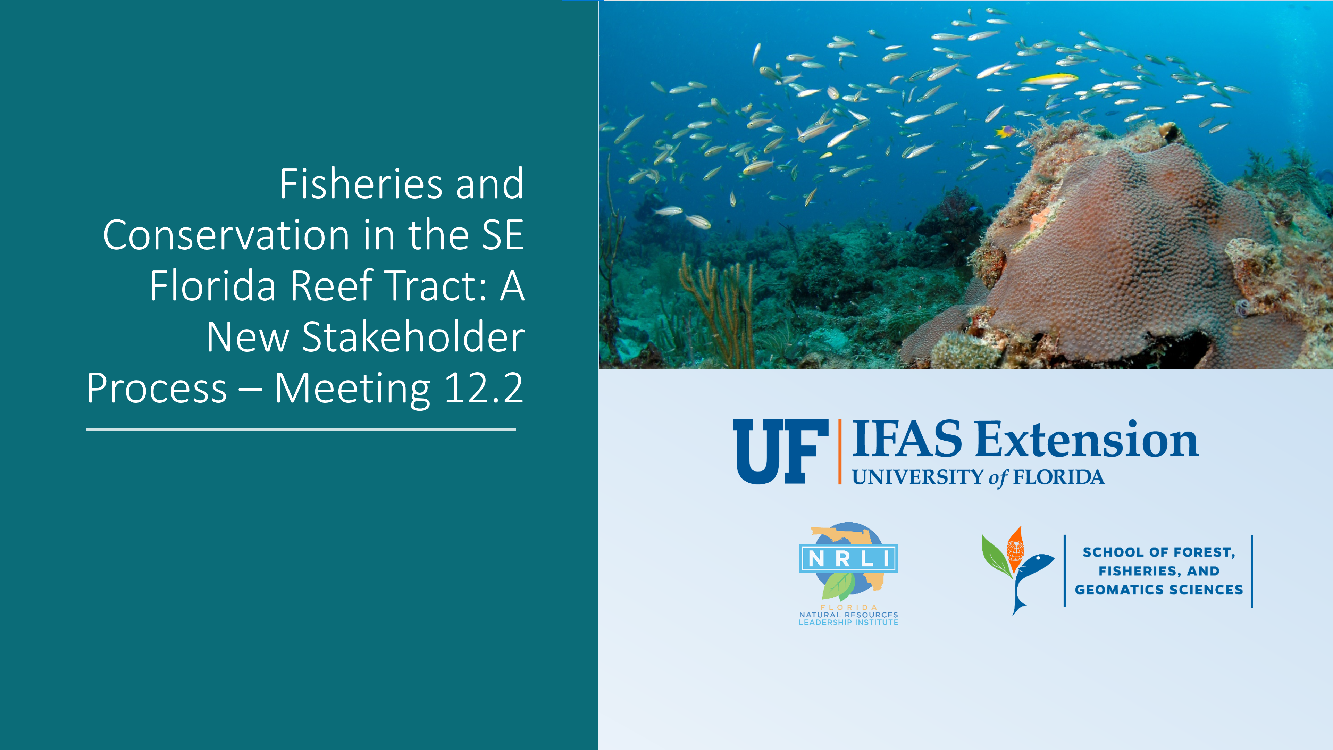
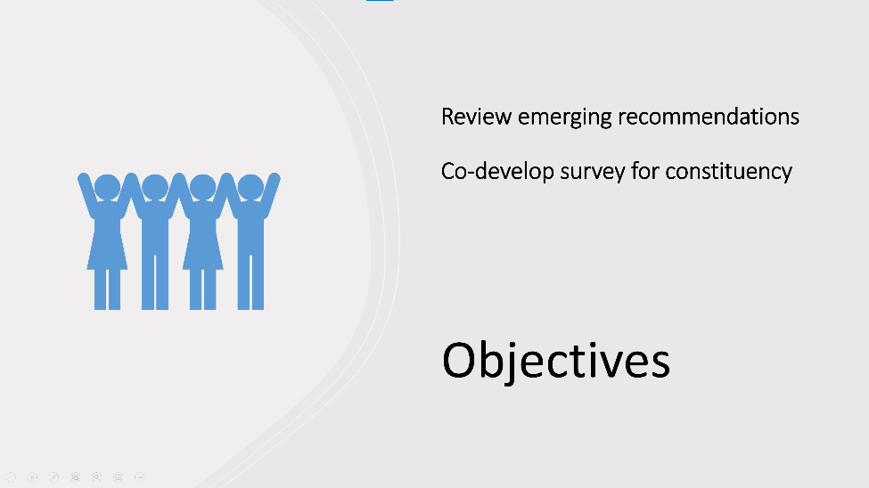
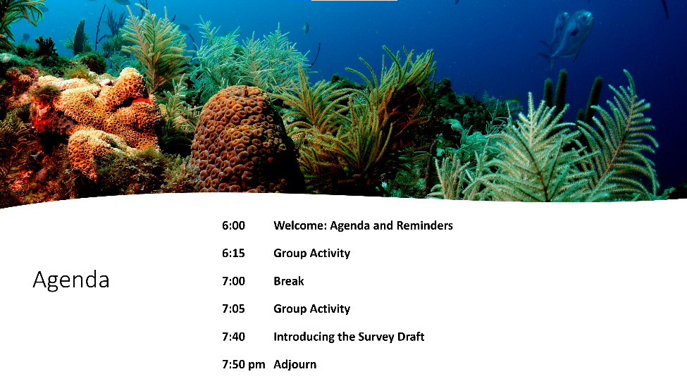

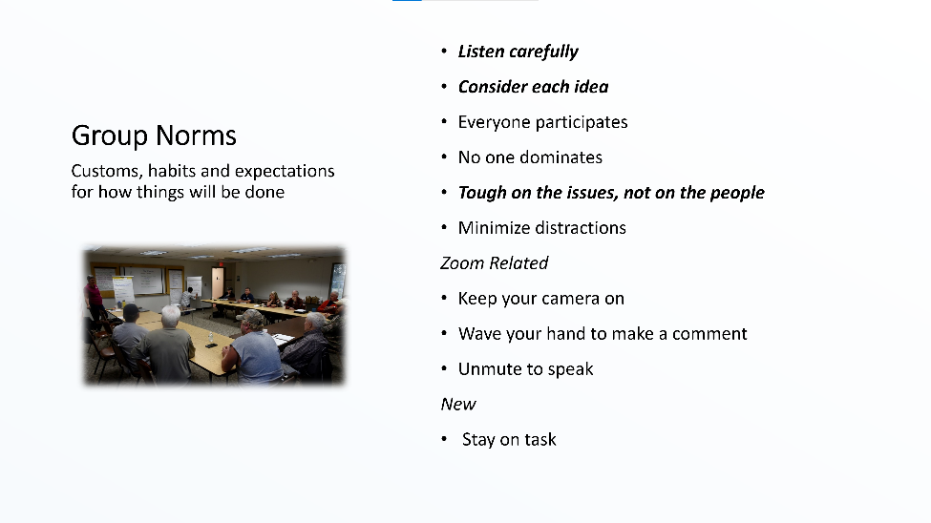
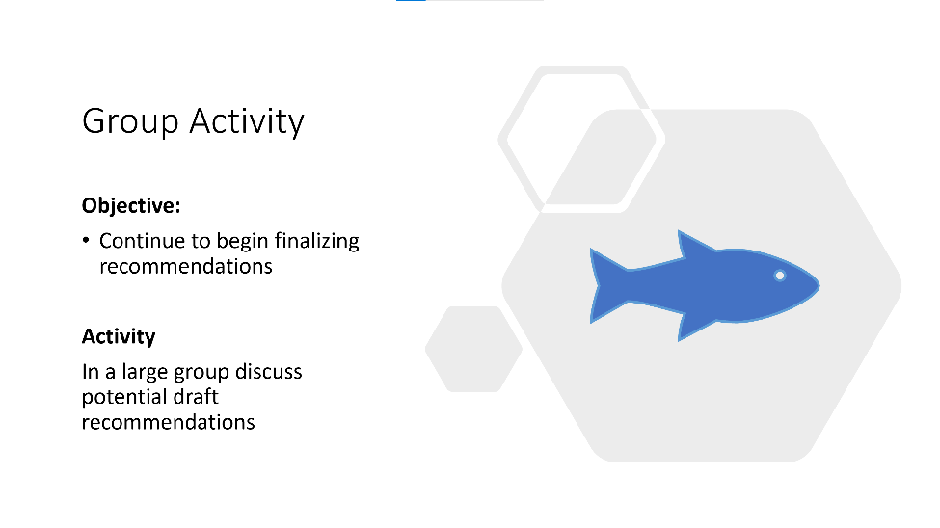
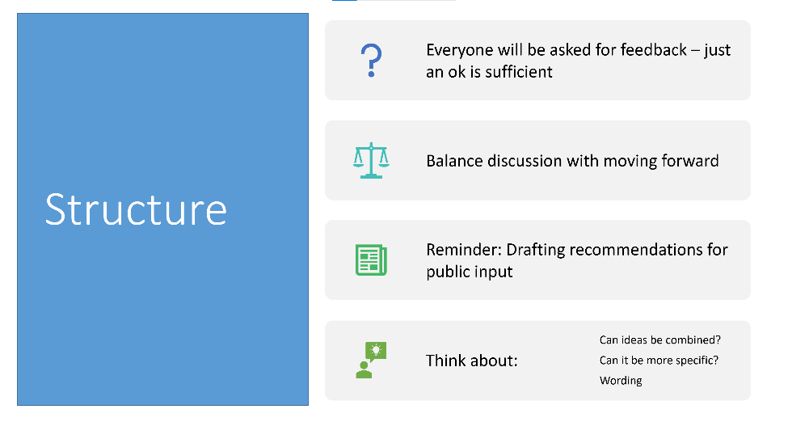

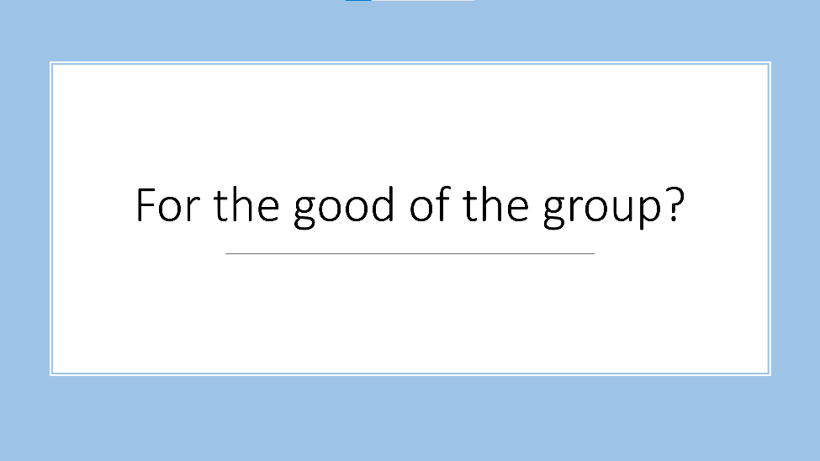

Appendix 2
00:48:13 Kellie Ralston: Should probably include counties in that...
00:57:10 Derek Cox: (5)(a) Except as otherwise provided in paragraph (b), the department has exclusive authority to regulate the sale, composition, packaging, labeling, wholesale and retail distribution, and formulation, including nutrient content level and release rates, of fertilizer. This subsection expressly preempts such regulation of fertilizer to the state.
(b) An ordinance regulating the sale of fertilizer adopted by a county or municipal government before July 1, 2011, is exempt from this subsection, and the county or municipal government may enforce such ordinance within its respective jurisdiction.
00:57:34 Derek Cox: I can explain talk about above when we have a minute to go back to fertilizer
00:58:13 Kellie Ralston: https://www.flsenate.gov/Session/Bill/2020/712
00:58:51 Kellie Ralston: what about encourage full implementation of the clean waterways act?
01:21:05 Kathy FitzPatrick: mooring fields can only control activities within their boundaries and a 150 ft perimeter around them.
01:31:01 April Price: I like Gary's language recommendation & Marty's educational component
01:32:57 Kellie Ralston: Sweden and Switzerland use ozonation as a step beyond advanced wastewater treatment to remove pharmaceuticals and PFAS.
01:37:32 Kellie Ralston: No additional comments tonight. Thanks for letting me speak earlier!
01:39:43 April Price: Thank you Susana & Joy! Happy Easter to all!!🐰
01:40:46 April Price: & Passover too!

